Skybrook Phase 10 Mailbox Standards

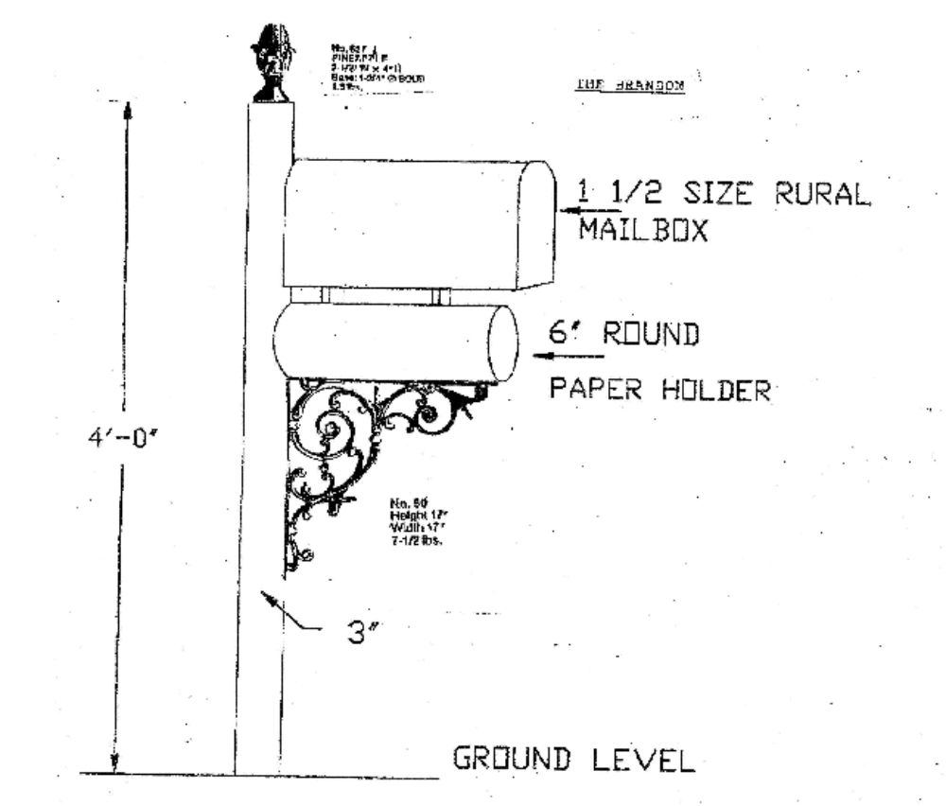
The post is a 3” square post and has a pineapple finial. The mailbox is mounted to a newspaper holder/scroll bracket which bolts on the post and has white reflective house #’s on both sides of the newspaper holder. The newspaper holder is a 6” diameter round tube. The mailbox itself is a large rural rolled steel black box.

All parts including the decorative scroll are made of aluminum and have a powder coated black finish. Aluminum components do not rust and are virtually maintenance free. Because mailboxes made of entirely of steel components rust after about a year, aluminum materials are preferred.

